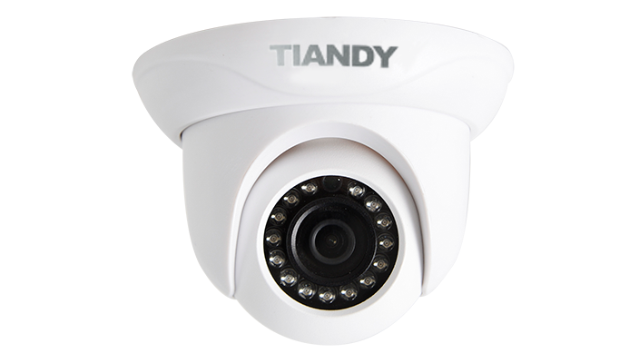

Features

• Up to 1920X1080 High Resolution  
• Full HD 1080P Video  
• IR Range: 20m  
• NIR, WDR, 3D DNR, HLC, Dual-ICR  
• Triple Streams  
• Tripwire Detection  
• Perimeter Detection  
• TVS 6000V Protection, IP66

Specification

|  |  |
| --- | --- |
| Camera | |
| Image Sensor | 1/2.8″ Sony Exmor CMOS |
| Core Processor | ARM9 Architecture |
| Operating System | Embedded Linux |
| Signal System | PAL/NTSC |
| Min. Illumination | Color: 0.05 Lux @(F1.2, AGC ON) |
| B/W: 0.01Lux @(F1.2, AGC ON); 0 Lux with IR |
| Shutter Time | 1s to 1/10,000s |
| Lens | 2.8mm/4mm, Angle of View: 90°/74° |
| Lens Mount | φ12 |
| Auto Iris | DC Drive |
| Day& Night | IR Cut Filter with Auto Switch |
| Wide Dynamic Range | 100 dB |
| Digital Noise Reduction | 3D DNR |
| Compression Standard | |
| Video Compression | H.264/MJPEG |
| Bit Rate | 32Kbps~16Mbps |
| Audio Compression | G.711/G.726/ADPCM |
| Bit Rate | 8K~48Kbps |
| Image | |
| Max. Image Resolution | 1920×1080 |
| Frame Rate | 50Hz: 25fps (1920 × 1080), 25fps (1280 × 720) |
| 60Hz: 30fps (1920 × 1080), 30fps (1280 × 720) |
| Triple Stream | Mainstream:1080P(1920*1080) |
| Substream:D1(704*576) |
| 3rd stream:CIF(352*288) |
| Image Settings | Brightness, Saturation, Contrast,Flip Mode Adjustable by Client Software or Web Browser |
| HLC | Y |
| Smart Defog | Y |
| Corridor | Y |
| EIS | Y |
| ROI | 4 Zones |
| Privacy Mask | 4 Zones |
| Picture Overlay | 200 × 200, BMP 24bit, Zone Configurable |
| Network | |
| Browser | IE 7+, Chrome 18 +, Firefox 5.0 + |
| Network Storage | NAS |
| Video Analytics | Tripwire/Perimeter |
| Alarm Trigger | Motion Detection/IP Conflict/MAC Conflict/Port Alarm |
| Protocols | TCP/IP/ICMP/HTTP/HTTPS/FTP/DHCP/DNS/DDNS/  RTP/RTSP/RTCP/PPPoE/NTP/UPnP/SMTP/SNMP/  IGMP/802.1X/QoS/IPv6/Bonjour |
| User Permission | 4 Level/8 Users |
| System Compatibility | ONVIF (Profile S),  SDK |
| Interface | |
| Audio Input | N/A |
| Audio Output | N/A |
| Communication Interface | 1-ch RJ45 10M / 100M Ethernet Interface |
| Alarm Input | N/A |
| Alarm Output | N/A |
| Video Output | N/A |
| On-board Storage | N/A |
| Extension | N/A |
| General | |
| Operating Conditions | -35℃～60℃(IR OFF) /-35℃～40℃(IR ON), 0～95% RHG |
| Power Supply | 12 VDC ± 10%, PoE (802.3af) |
| Power Consumption | Max 5W |
| Circuit Protection | TVS 6000V, Lightning/Surge 1000V Protection |
| Impact Protection | IP66 |
| IR Range | 20m |
| IR LEDs | 15pcs IR LEDs |
| Dimensions | 119mm×119mm×85mm |
| Weight | 300g (IP Camera Only); 500g (with Packing Box) |

Dimension

[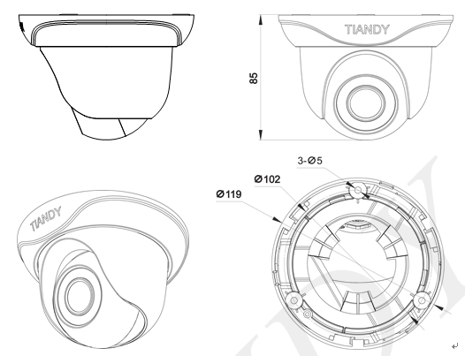](http://en.tiandy.com/wp-content/uploads/2015/07/14.png)